**Use the RACES format to answer the question: What three biological processes do scientists mimic to make the micro-robots become fluid or assembly themselves into a solid shape?**

**Scientists develop micro-robots that can flow like a fluid or collectively assemble into solid shapes**

*By* [*Alfonso Maruccia*](https://www.techspot.com/community/staff/alfonso-maruccia.491138/) *February 26, 2025 at 4:22 PM*

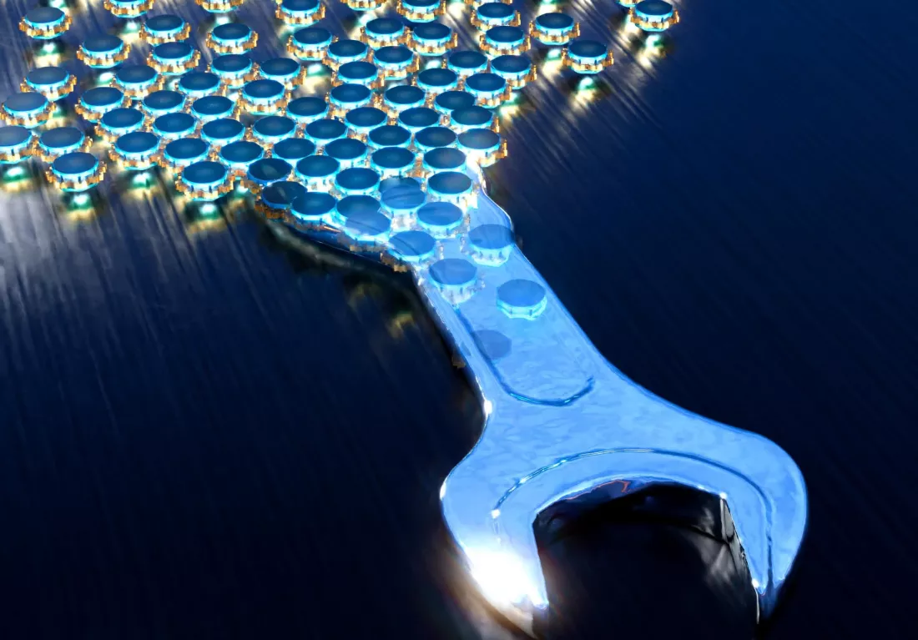

**In a nutshell:** Researchers have developed minuscule robots that can "assemble" and behave like a collective, building new shapes and tools. Inspired by nature, the team identified and developed the main features a robotic collective would need to achieve its programmed goal.

Researchers from the University of California, Santa Barbara (UCSB) designed a "material-like" collective of programmable micro-robots, which can behave like a fluid or bond together to create new solid structures. The technology could lead to the development of a new sub-field of robotics.

The UCSB scientists set out to design simple robots that could work together, like a colony of ants or other collective groups. The study, recently [published](https://www.science.org/doi/10.1126/science.ads7942) in Science, describes micro-robotic units that can switch from a "fluidizing" state to a more "solid" shape based on the rotational state of the robots.

The idea is ripped straight from science fiction concepts like the T-1000 from Terminator 2: Judgement Day. The researchers claim they have turned this theoretical vision into reality after studying embryonic morphogenesis, the biological process through which cells can change their shapes and turn into different tissues in the human body.

Living embryonic tissues behave like the ultimate smart material, UCSB professor Otger Campàs told SciTechDaily. **These cells can self-shape, self-heal, and even control their material strength.** They can also temporarily soften, switching between solid and fluid states to develop the embryo's final shape.

The UCSB researchers identified three biological processes they could program their robotic collective to mimic: *interunit force, polarization, and adhesion.* **These three processes allow cells to move around together, coordinate their movement, and stick to each other while developing into a solid organic part.**